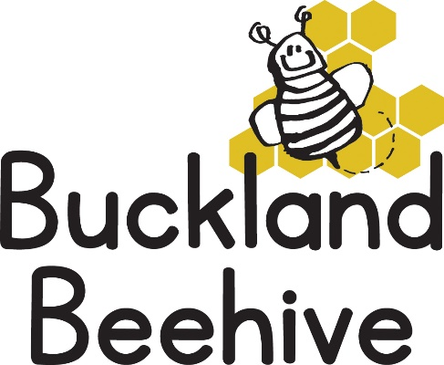

15th April 2024
Welcome back to another busy term at Beehive. We hope you all had a lovely Easter break, despite the weather! We did have a lovely weekend so lets hope the dry weather continues.
This term we will be talking about Transport and ways of getting around, starting with looking at ourselves “Walking & Running”, opposites of fast and slow, our skeleton and learning about the parts of the body, with lots of games related to the movement of our bodies. We will also be doing a refresher of the phonics that we have learnt so far.
We welcome three new children on Monday, Billy, Sibyl and Joey, so we hope they enjoy the activities we have out.
A reminder that as the weather is still so unpredictable, named wellies and waterproofs please, as well as a named drinks bottle for your child.
If you have any questions or concerns please do talk to Tara, Angie Debbie or myself, or send an email to bucklandbeehive@hotmail.com
Many Thanks

