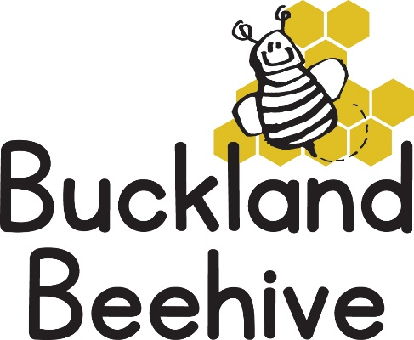

12th January 2026
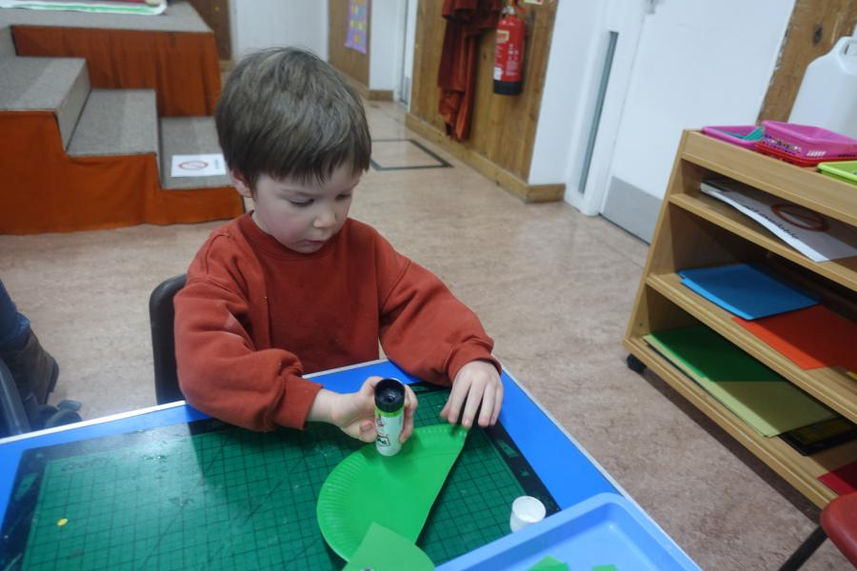
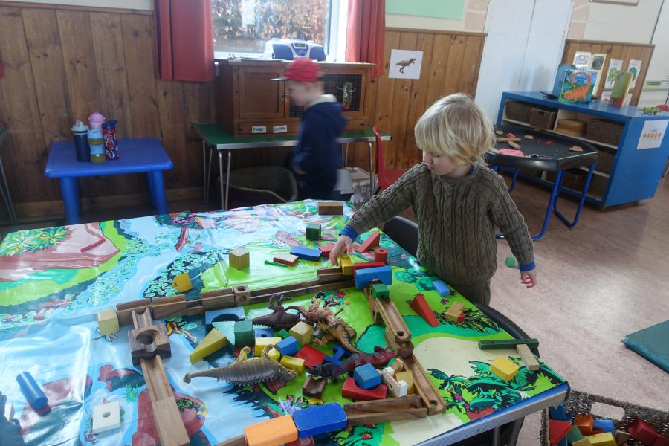
The children have returned to Beehive full of enthusiasm for our theme of Dinosaurs, they made some great T Rex craft and here Joey has made a dinosaur enclosure!
This week we will be learning about a Stegosaurus, which was a herbivore, so we will also be talking about eating healthy fruit and vegetables. On our sensory table we will have some dinosaurs hidden in ice, how long will it take to melt and free the dinosaur?
Phonics this week will be looking at the letters “m” and “a”.
Joey will have his 4th Birthday this week, so Congratulations, we will celebrate with cake!
Please can you send your child in with named welly boots and waterproofs, it is particularly muddy in our garden and we only have a limited supply of spare outdoor clothes. Also, if your child comes to Preschool in wellies, can you put some shoes in their bag as well so we can change them after being outside.
Many Thanks

