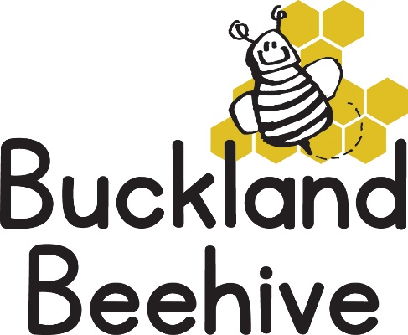

23rd February 2026
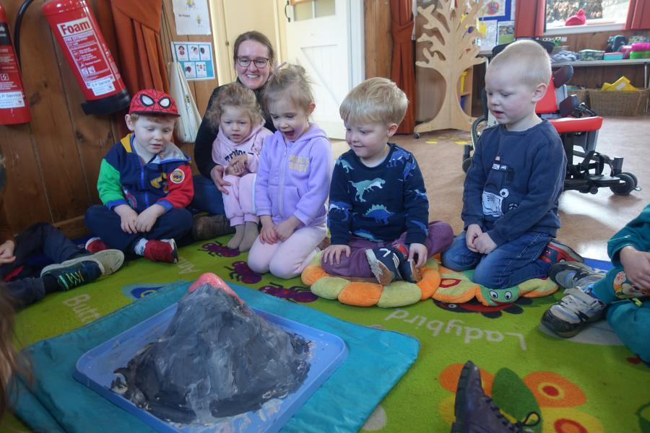
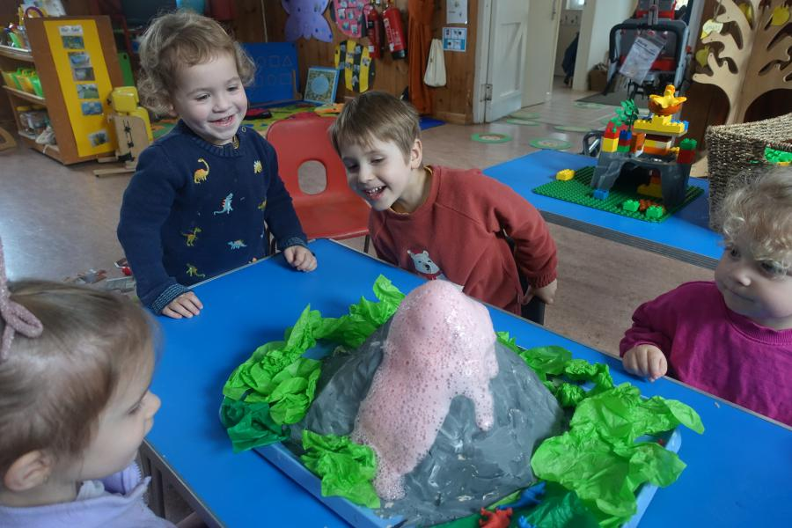
Welcome back, we hope you all had a lovely half term. I just wanted to show you that in the last week of term the children saw our volcano erupt with spectacular effect! There are other photos on our Parent Gallery on our website.
Our theme this half term is Minibeasts and this first week we are looking at creatures that “Creep & Crawl”, so snails, worms and caterpillars, we will also be taking delivery of our own caterpillars that we hope will transform into butterflies the last week of term. We will be making paper plate snails and hungry caterpillars as well as creating another amazing picture board.
This first week back we will be going over the Phonic sounds that we learnt last half term, just as a reminder to the children.
We are adding to our Makaton vocabulary, so far, we are using “more”, “help”, “toilet” and this week we will be learning “please” and “Thank you”.
Please remember named wellies and waterproofs as the garden is still water logged! And rename your lunchboxes and drinks bottles for us, that would be much appreciated.
We will be welcoming Jo to Beehive, as she starts work on Tuesday. I am sure the children will soon get to know her as she joins in with their activities.
Many Thanks

