

20th October 2025

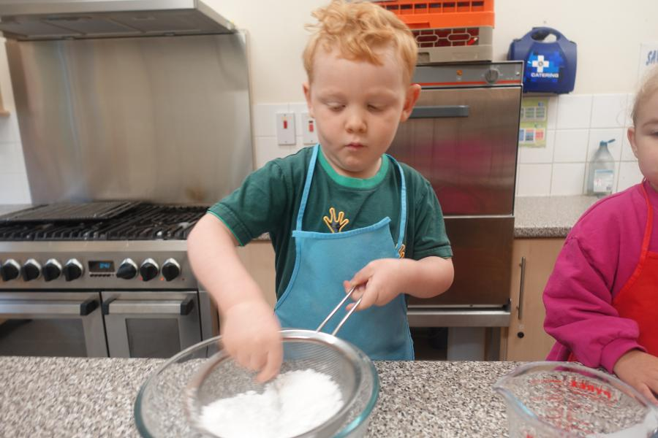A busy week building towers as big as ourselves, the best part was knocking them down! Painting, shopping and cooking funny faces, looks a serious job!

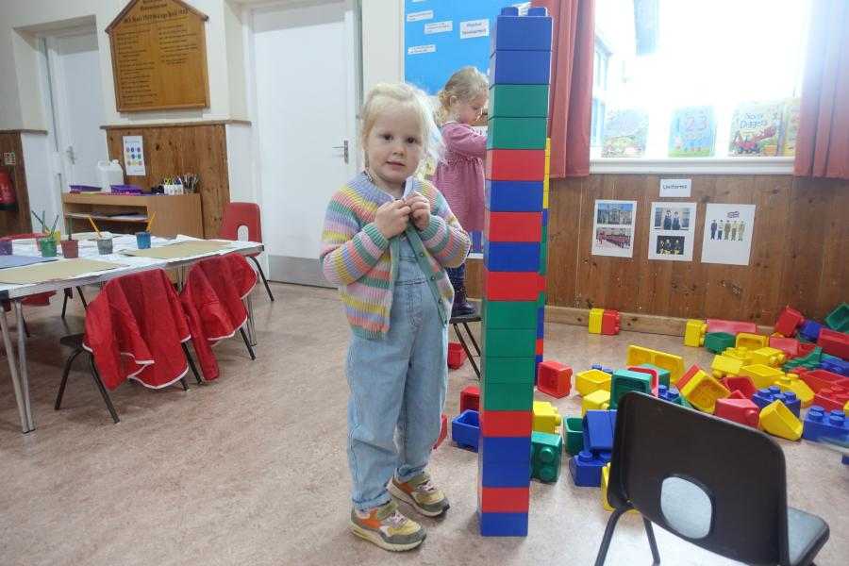

This week it is all about People who help us. We have a visit from Dartmoor Fire & Rescue on Thursday morning. Christine will be joining us at 9am and talking to the children about her job, bringing in equipment and her rescue dog for us to meet.

Everyone is invited on Thursday, we only have a few children booked in so to make her trip worthwhile anyone who would like their child to see how the Rescue team work on Dartmoor can come in. She will be with us for about an hour from 9am, so do join us.

We will also be looking at the important jobs of a Dentist, Optician, Police, Farmers and Firemen, the children will be pleased to know we will have the dressing up out. We will also have pumpkins galore! As we approach Halloween.

This is our last week before half term, and we will be back on Monday 3rd November all ready to start the Christmas countdown.

Many Thanks