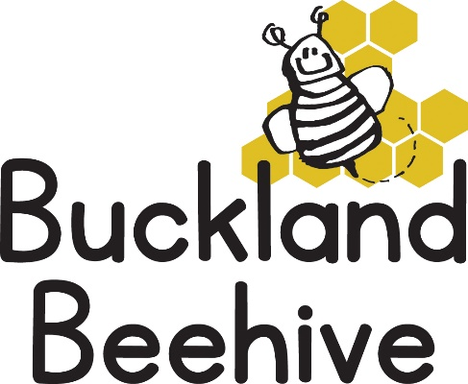

15th September 2025

A varied week with the weather, we were able to dash in and out of the showers, and had some splashy fun in the puddles!

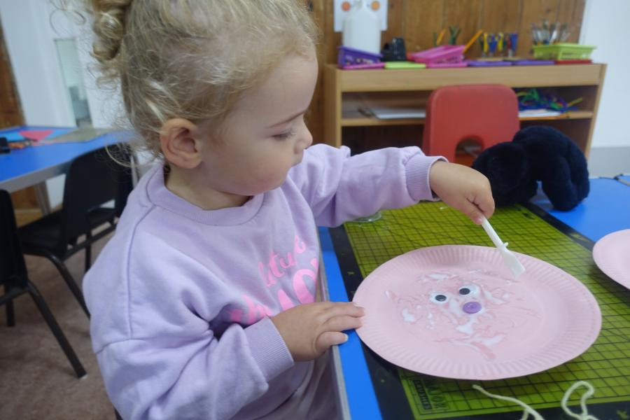We continued to make our faces, and we also made x-ray pictures of our hands using cotton buds as bones!

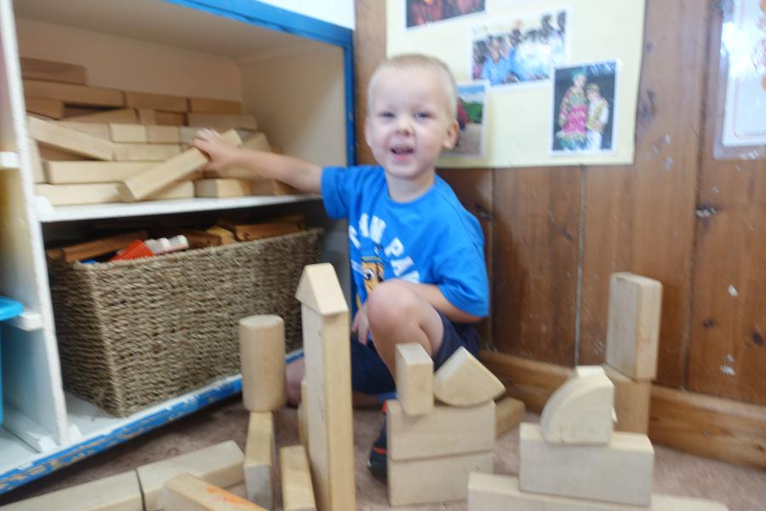Billy made some great towers with the blocks, continuing our group building game at Circle time, well done!

This week we are all about Healthy Eating. During the week we are going to make a hearty vegetable soup, and the children can make their own fruit kebabs for snack time, vegetable printing on the craft table and pasta on the sensory table.

It is not all healthy, as on Wednesday we have George’s third Birthday, so we will be celebrating with cake!

We have started to put a library book in your child’s bookbag, they choose a book which they would like to share with you at home and then we change them the following week. Hopefully this will encourage a love of books and reading for the future!

Thank you for all your efforts at labelling your child’s belongings, it is much appreciated!

Thank you