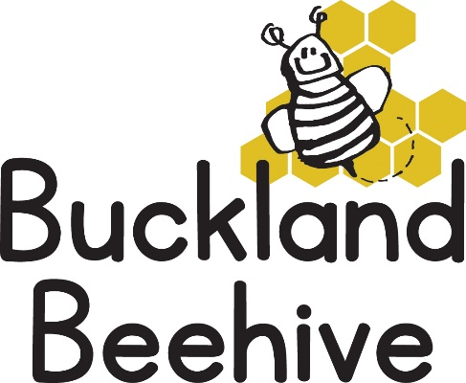

6th July 2026
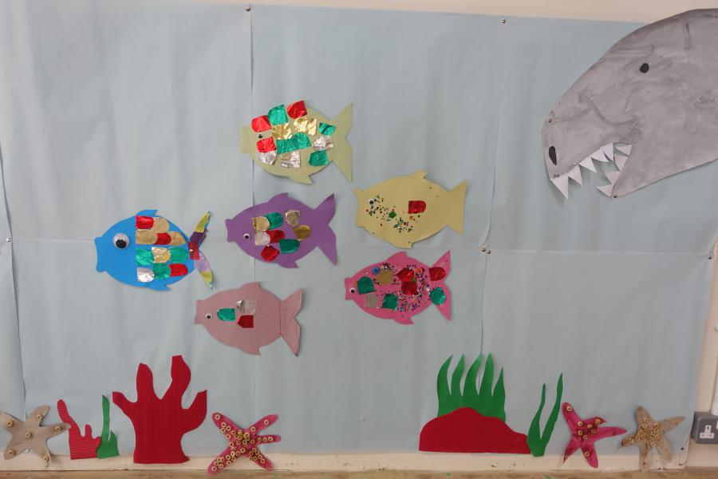
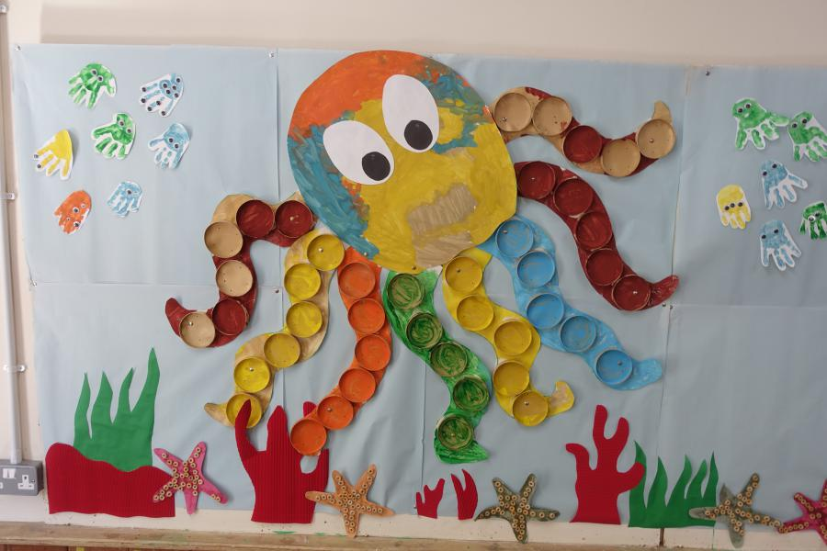
Our theme board is looking really great at the moment, we have added some handprint jellyfish and requests were made to add a shark, although it does look a bit like a dinosaur! We looked at sea transport and made boats in craft, the children are really taking on board all the different types of sea creatures that live in and by the sea, do bring in any interesting finds if you visit the beach over the weekend, we love to talk about them at circle time.
This week we are going to have a Pirates & Mermaids week! dressing up, hiding treasure, making treasure maps and mermaid mirrors and generally having a good time.
The weather is looking good all week, so remember to apply sun cream to your child before they come to Beehive, and sun hats please.
Unfortunately, we will not be having swimming on Tuesday as the school have a biathlon and are using the pool all afternoon. Transition will resume for the children starting school on Thursday afternoon and there is a transition session that the school have organised on Wednesday afternoon. If you are taking your child, please collect from Beehive after 1pm and don’t forget to collect them from the school at 3pm. Any questions, do let me know.
Just a reminder that our Sports morning is arranged for Friday 17th July, 9.15am until 9.45am, everyone is welcome to join in, drop off is at 9am, further details in next week’s newsletter.

