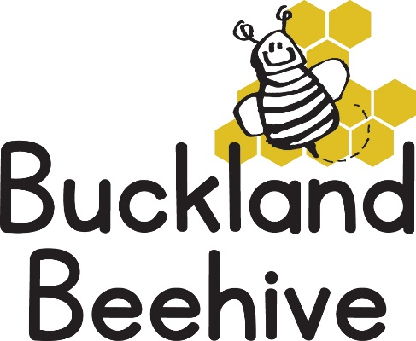

5th January 2026
Happy New Year
We hope you have all had a wonderful Christmas with your children, I am sure they will have lots to tell us this week.
We are open on Tuesday 6th, weather permitting. Tara, Angie and Amber live outside the village and with the current weather conditions I am preparing you all in case they are unable to drive in. If this is the case Beehive will be closed, I will of course keep you informed on a daily basis via email first thing in the morning, if needs be.
Our theme this half term is DINOSAURS! And we will be looking at the T-Rex in the first week. Making a T-Rex with a paper plate, dino footprints in playdough, magnetic dinosaurs and much more.
We will be starting to teach Phonics to the children that will be starting school in September. This will take place daily with a short session in the side room introducing the children to the shape and sound of each letter in preparation for the next stage in Foundation. We teach Phonics via the Read & Write process, which you can google if you would like to know more about it, this is in line with St Andrews School.
We welcome Harry this week, he will be joining Beehive for his first sessions and hope he enjoys the dinosaurs!
Many Thanks

