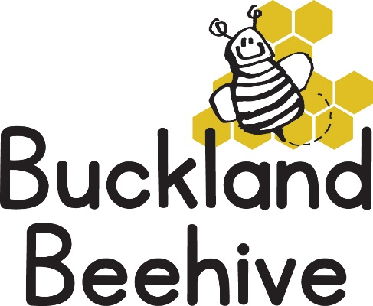

8th December 2025
The children are really ramping up their excitement for Christmas already! We enjoyed our last Fairy Tale of the Three Billy Goats Gruff by making some great goat heads in craft.
For the next two weeks we will be concentrating on the Christmas countdown, making some great craft and decorating both our trees, one which is supervised and the other is a free for all, pictures will follow!
We have our Christmas Show on Friday 12th. Please drop off your children at the usual time of 9am, and if you could wait patiently outside, (hopefully it will not be raining), until we are ready. I will let you all in around 9.15am, the whole sing song only lasts about 20 minutes, but we hope you enjoy our efforts.
The children can dress up in whatever they want, it can be Christmas themed or anything else, we have had Spiderman in the past, so anything goes! After the show, the children will return to the side room, and if your child is not normally booked in on a Friday, you can collect your child from the side room and leave.
Some help to put the chairs away after the show would be much appreciated, as we will need to set up the hall for the session to continue.
Many Thanks

