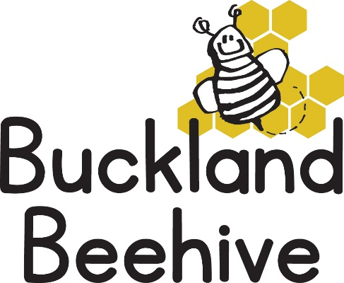

21st September 2026
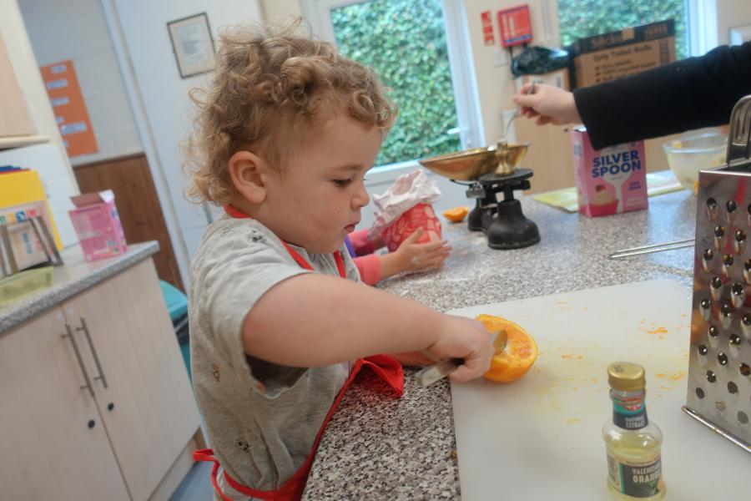
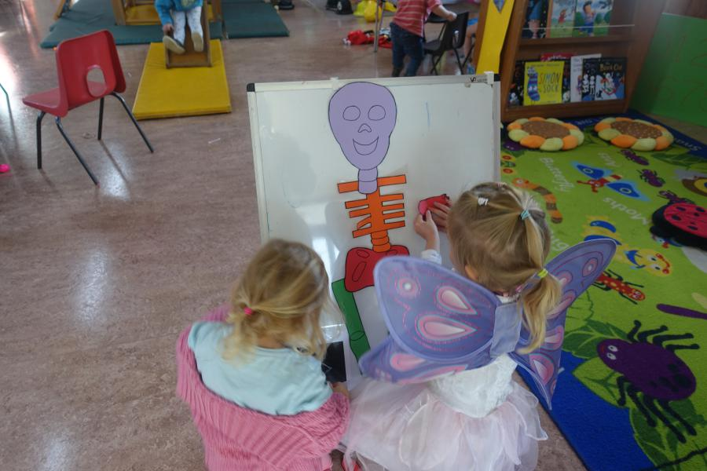
A busy week learning all about our skeleton, the children enjoyed putting together our homemade skeleton and we made some bone biscuits all the children loved the cooking activity, and the end result!

This week we will be looking at being healthy and keeping fit. The hall will be laid out with an assault course, jumping frame, trampoline and balance beams. We will look at what foods are good for us and which ones should be a treat, we will also be having some different fruit for snack time as well as trying foods from around the world
On Wednesday we share the hall with The Charlston Friendship Café, they are a volunteer group set up so the elderly, Alzheimer sufferers and carers in the community can come together for some activities with tea and cake. They have invited Beehive children this Wednesday afternoon to join them making Autumn leaf pictures with hand prints and reading books about Autumn. It has been well documented the benefits to both children and the elderly when they interact, it will only be for an hour and children will continue to be collected from the side entrance at 3pm. We hope they will enjoy the experience, especially as they have always wanted to see what goes on in the hall when we are in the side room.
On Thursday we have another Birthday, Hattie will be four years old, and she is very much looking forward to it!
Many Thanks

