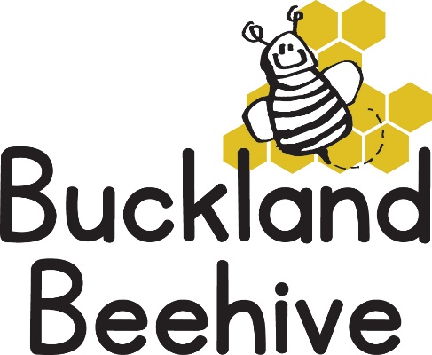

17th November 2025
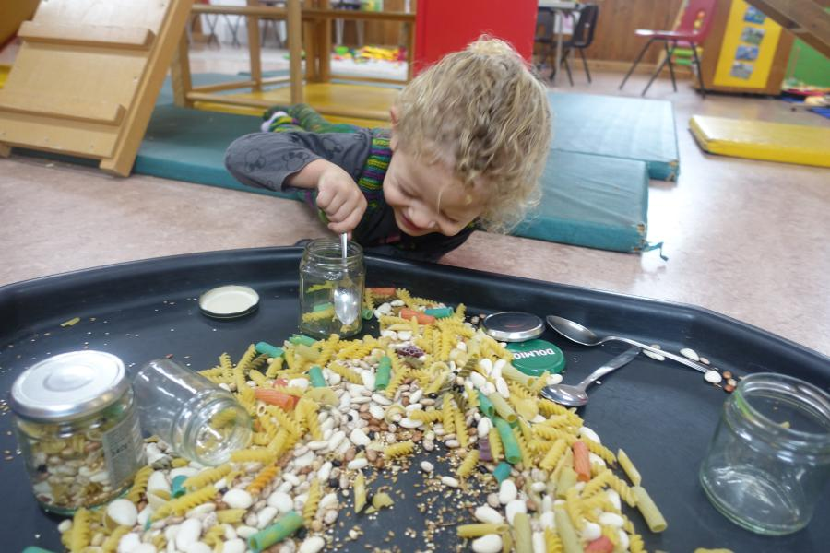
With a lot of roaring like giants and stomping around the hall, the children totally took on board the story of Jack and the Beanstalk. Some of the children planted their own magic bean, made castles out of the giant bricks and made a beanstalk in craft. Here Polly is putting beans into jars great for hand eye coordination.
This week we will be reading Little Red Riding Hood, we will be making wolf masks, dressing up, cooking cakes for Grandma and making playdough cakes on the sensory table. Another classic tale which talks about our senses, what we can hear and see and taste.
We will be celebrating Alice’s third Birthday on Tuesday, so some extra cake for us to enjoy too!
We have the School Christmas Fair coming up on the 28th November between 5pm and 7pm. Everyone is invited, Father Christmas will be there in his Grotto, and there will be lots of stalls for you to look round, including our stall of the soft toy tombola, which is usually very popular. Don’t forget if you have any soft toys at home you would like to donate, please drop them into Preschool.
Many Thanks

