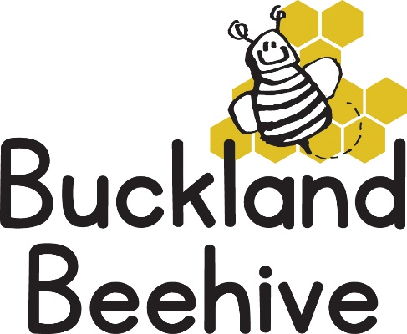

19th January 2026
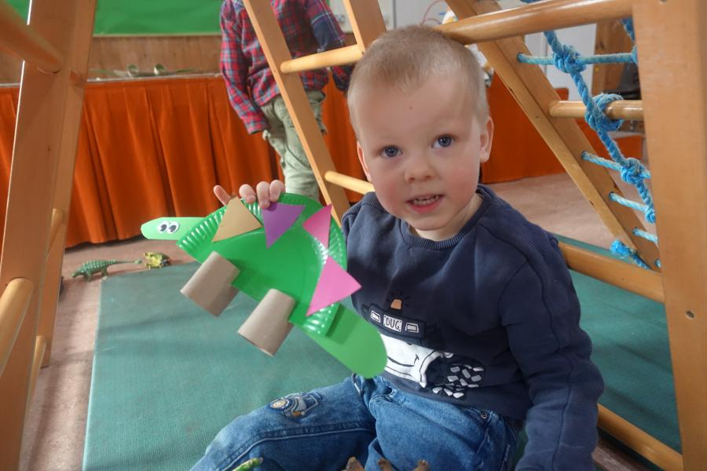
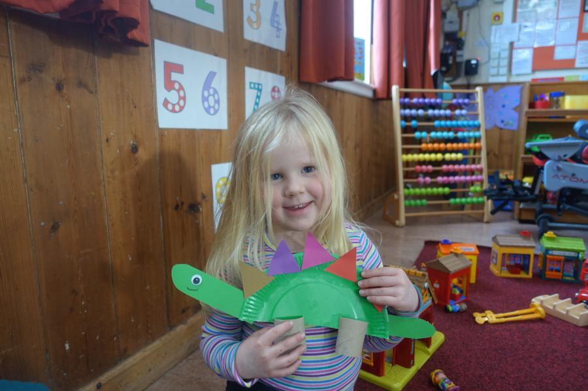
The children are really loving the dinosaur theme, and made some great Stegosaurus last week, well done. We had some dinosaurs trapped in ice and waited for the ice to melt to free the dinosaurs, we had dinosaurs hidden in the sandpit and we finished another ginormous dinosaur for our theme board.
This week we are learning about the flying Pterodactyl, making some more models in craft, and a giant picture for our theme board as well as making dino biscuits. Phonics this week will be “s” and “d”.
We end the week by celebrating Auben’s 3rd Birthday!
Unfortunately, it is that time of year when I need to address rises in costs coming up in April, I managed to hold off raising the hourly rate last year, but I feel that it is now unavoidable. So, from 21st April when the Summer Term starts our hourly rate will increase to £5.50 per hour. We are still the most reasonably priced childcare facility in the area as I have been very conscious of not overpricing but still managing to offer outstanding care for your children.
If you have any questions or concerns, do contact me anytime.
Many Thanks

