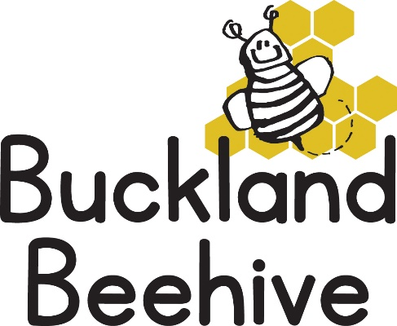

4th September 2025

Welcome Back!

We hope you have all had a super Summer break, we did have some great weather, which always makes a difference. We also hope the children are looking forward to coming back to Beehive as much as we are looking forward to seeing you all again.

Our theme this term will be “All About Us”, and we will start by looking closely at ourselves and seeing what we look like, during the term we will be making a life size picture of each child, which the children will dress and our first job is to make a copy of our faces out of a paper plate!

Can I ask if you could also bring in a shoebox for your child too, as we will decorate them and put their treasures inside, including pictures of family, friends and pets which we will accumulate during the sessions and will be sent home at half term.

As the weather starts to change, please prepare by naming wellies and coats, we will be having a muddy day session on a Friday down at the School with Foundation class starting next week, so full waterproofs are needed if your child attends on a Friday.

Please also name your child’s water bottle and lunchbox, it makes it so much easier for us and less likely that they will get lost!

Only a short week this week, but already packed with activities!

Many Thanks