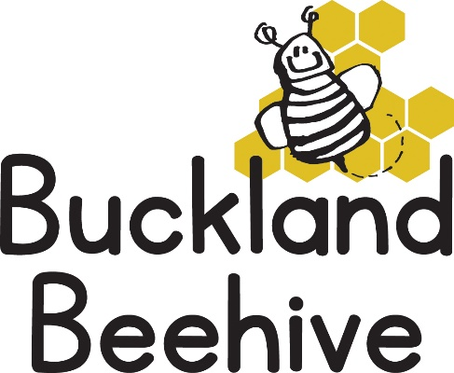

22nd April 2024
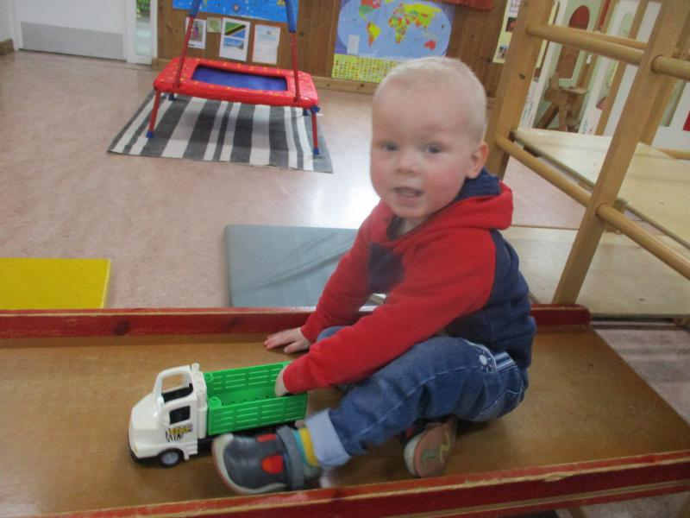
We had a lovely first week back, our new children settled in to the routine, and Imogen will be starting on Monday, which means we are full every day of the week! with this in mind we are now unable to swap children’s days around anymore, unless a space becomes available. I have always capped our sessions at 16 children per day, so that we are always over our ratios with 3 members of staff. As I am unable to help out at this time, Sarah Hughes has returned to assist Tara, Angie and Debbie wherever needed.
The children enjoyed learning about their bodies and how we move around, this week we will be looking at “cars and motorbikes”, seeing if we can spot numbers and letters on car numberplates, we will be making paper plate cars for our display board and making tracks through the playdough with wheels. Our phonics this week will be “b” & “f”.
During the week of the 29th April we will be talking about bicycles and scooters so we would like to carry out a sponsored cycle around the hall, with the children riding our bikes and cars. We would like to save up and purchase either one or both of these bikes for our outdoor play area. We will send a sponsor form home with your child and lets see how much we can raise!

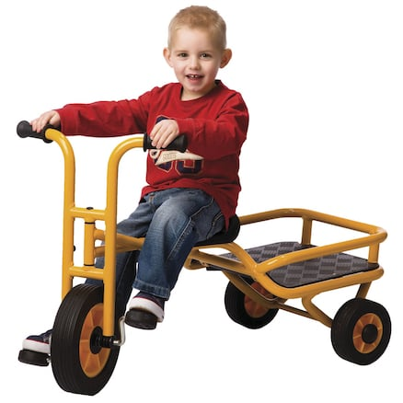
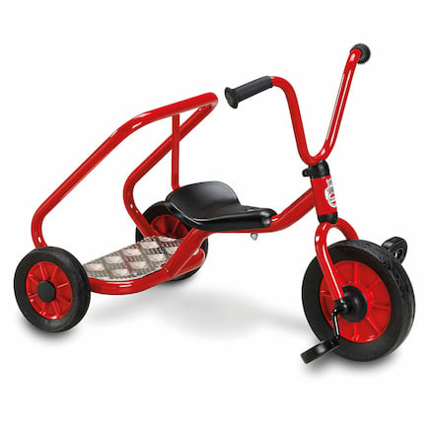

£124.99 £269.99
This will be in two weeks, so lots of time to get Grandparents on board for that extra sponsorship bid!

Many Thanks

