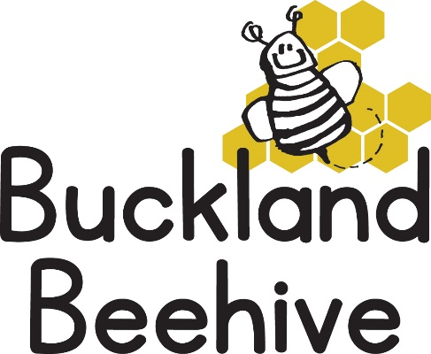

1st June 2026
Welcome Back! We hope you have enjoyed a fabulous week in the glorious sunshine, how lucky were we all! Let’s hope it continues.
The theme this half term is Oceans and Sealife, with our first week looking at Planet Earth and seeing that we are surrounded by oceans. We will be making our own bottle of the sea, and a paper plate planet Earth.
The hall is being used for the Drama Group Play from Thursday night if you are interested in going details are on the front door of the hall. Preschool will continue as normal, it just means we need to clear the hall in the afternoon on Thursday and Friday, with the help of the children as well.
Transition sessions to St Andrews School start this week, on Thursday afternoon, Tara and Angie will walk the children to school for 1.30pm, stay with them and return to the hall for the end of the preschool session at 3pm. Amber and myself will take care of the younger children at the hall in their absence.
Unfortunately, the pool is not ready at the school so it looks unlikely that we will be able to have some swimming sessions this term. If the situation changes, I will let you know.
Please remember named sun hats and sun cream your children before they come to Beehive, that would be really helpful.
Many Thanks

