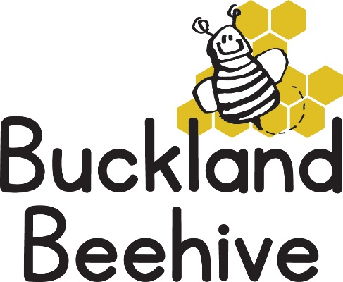

2nd March 2026
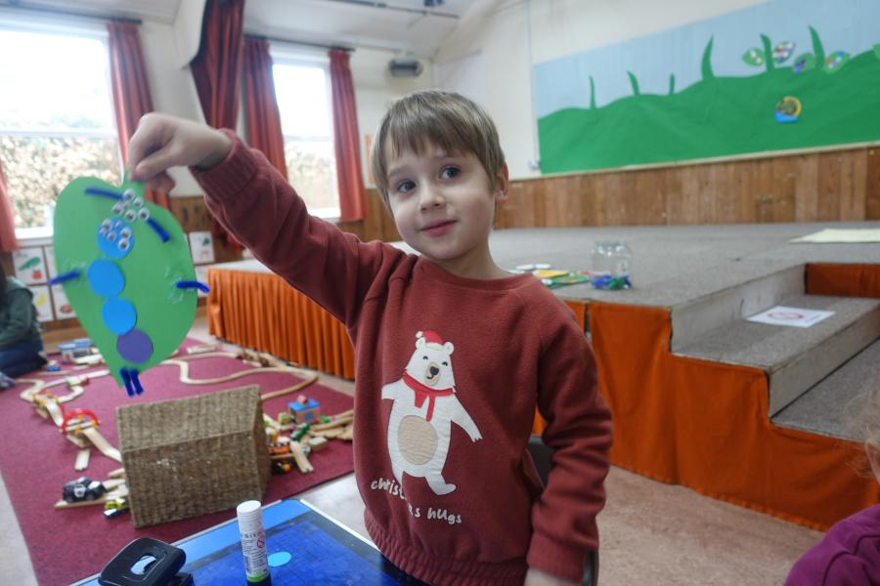
The children made a hungry caterpillar and snails for our picture board last week as we introduced our theme of minibeasts. We even have some real caterpillars that we hope we can watch grow and change into butterflies before the end of term.
We had a lovely visit from Lyndsey Walker, the Foundation teacher at St. Andrews School, on Friday, she introduced herself to all the children and stayed to play for a while.
This week we will be learning all about minibeasts that hum & buzz. Bees will be buzzing around, we have some honey toast for snack and making handprint bees to add to flowers that we will make.
We will be celebrating Angie’s Birthday on Monday, 21 again!
Keep sending in your child’s waterproofs, as the rain continues and the garden remains a muddy mess.
Many Thanks

