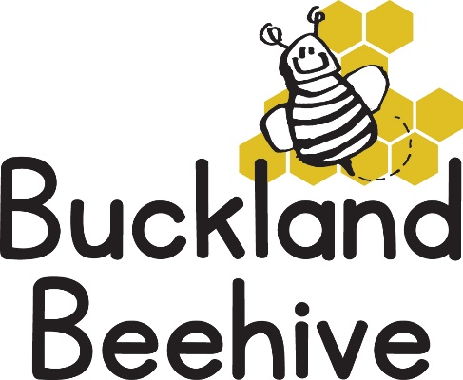

16th March 2026
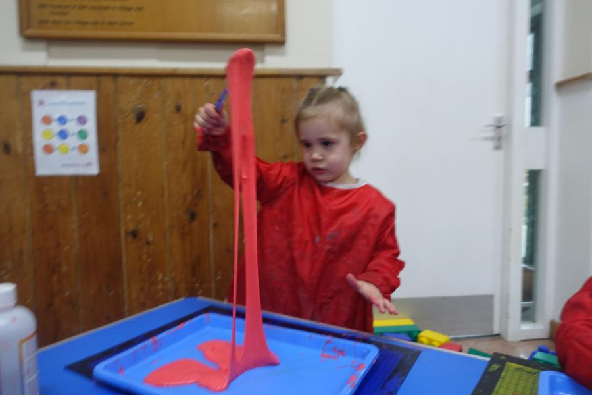
The children weaved their own spider webs last week which was fun, Tara made some stretchy, sticky slime, which the children loved playing with as well as the adults!

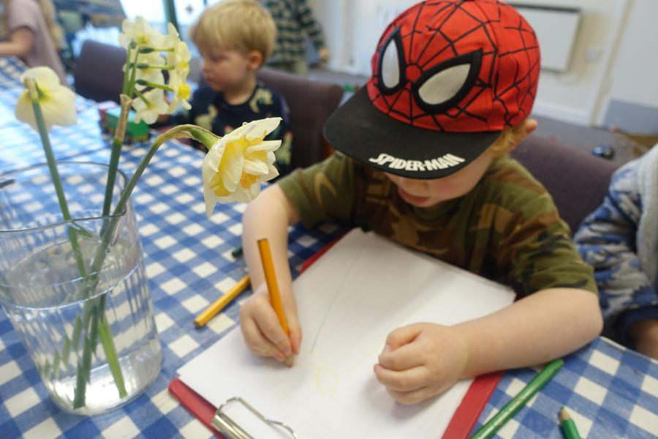
We also encouraged the children to draw their own version of some daffodils, the results were amazing, so well done to everyone who had a go. More pictures on our website.

This week we will be learning about minibeasts that “flutter & fly”, doing butterfly painting and making ladybirds. Our theme board is becoming very full of the children’s artwork and looking brilliant.
Phonics this week is “f” and “e” and we will be going over the Makaton signs we have learnt so far to help the children remember.
Thank you to everyone that has returned their lambing live forms with payment. Either pay with cash or via BACS straight into the Beehive Bank Account, whichever is easiest and if you haven’t returned your form, please try and get it back by next Friday at the latest.
I have a family wedding to attend on the 29th March and am stuck for someone to look after the guinea pigs for Beehive for that weekend, from Friday 27th and then return them to Beehive on Monday 30th March. Would anyone be interested?
You could take our hutch and accessories, (if it fits in your car), they are very friendly, I will provide fresh and dry food. First come first served, so if you are interested, please let me know as soon as you can!
Many Thanks

