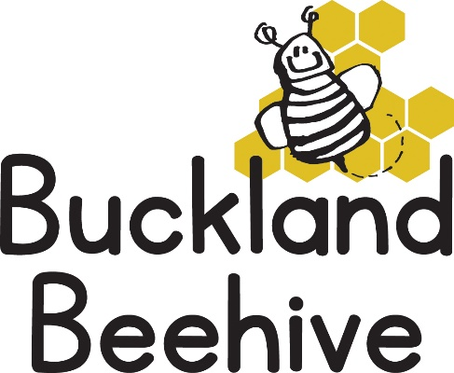

8th September 2025

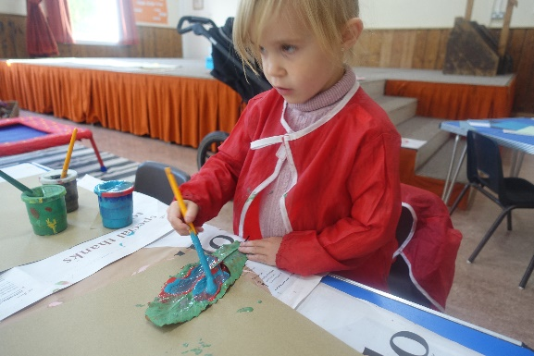A very quick start to the term last week, and a few tears from some of the children starting back after a lovely summer at home! This is to be expected, but once inside they soon settle back into the routine again.

Having found some super big leaves, we did some leaf printing, and they loved to see the guinea pigs again.

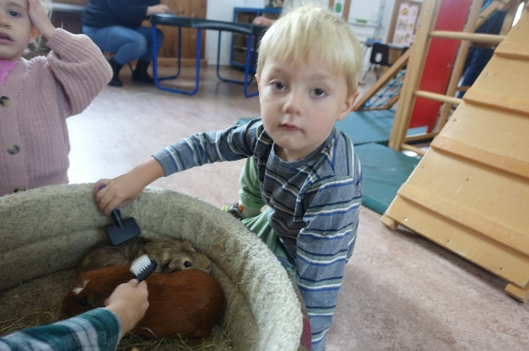

This week we will be making paper plate faces of ourselves, looking in the mirror and seeing what we look like, keep bringing in your shoeboxes so we can decorate them. We will also be talking about our skeletons and different parts of the body. If any one has an X-ray they could bring in, that would be amazing!

Please can you name your wellies, drinks bottles and lunchboxes.

Many Thanks