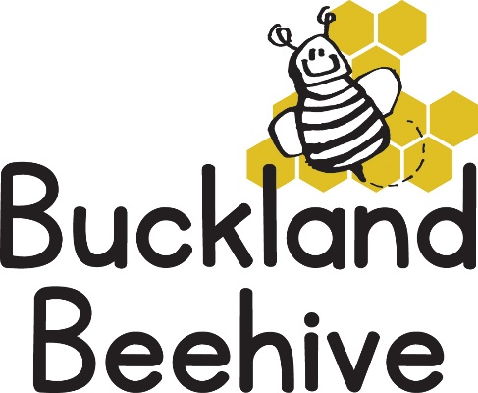

24th November 2025
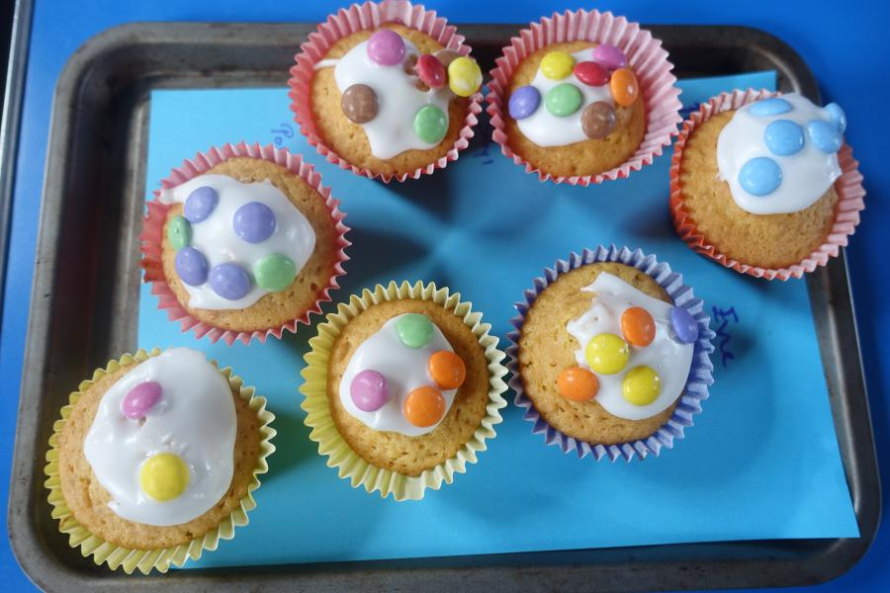
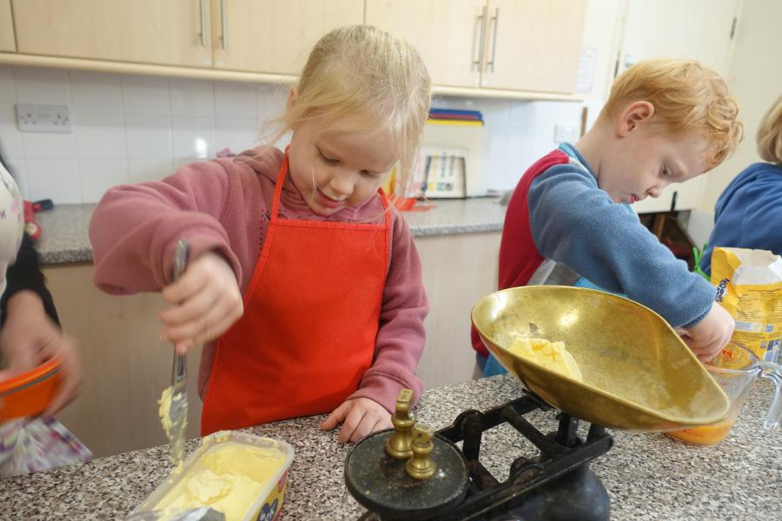
Little Red Riding Hood was a lovely story to read to the children, and they enjoyed making cakes for Grandma, as well as creating a wolf mask in craft and a red riding hood face on a lolly stick.
I hope the cakes were delicious, they certainly looked it, well done!
We did have some unexpected snow last week, all too soon it disappeared, but the temperature has definitely dropped, with this in mind can we ask that you send in a warm outdoor hat and gloves as the children’s fingers do get very cold, and we still want to make the most of going outside in the dry weather.
This week our story is Goldilocks and the Three Bears. We will be trying porridge at snack time, and playing with oats on the sensory table as well as making bears in craft. Another great fairy tale that the children will enjoy.
On Friday 28th at 5pm until 7pm, it is the At Andrews School Christmas Fair. Thank you to everyone for your donations of soft toys. Do come and see us on our table, it is a fun evening with various stalls and Father Christmas in his grotto! Any funds we make on our table will go towards our Christmas Party at the end of term.
We will be celebrating Henderson’s third birthday on Wednesday!
Many Thanks

