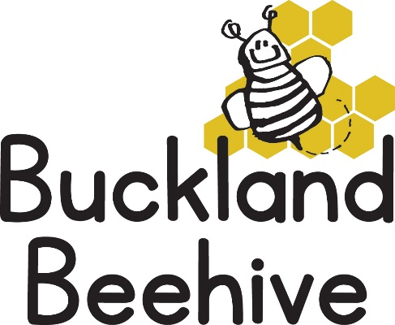

22nd June 2026
Angie bought some treasures from her visit to the beach which she shared with the children. We had seaweed, shells, cuttle fish bone and some rubbish which all contributed to our talk about plants and corals that you can find in and around the sea.
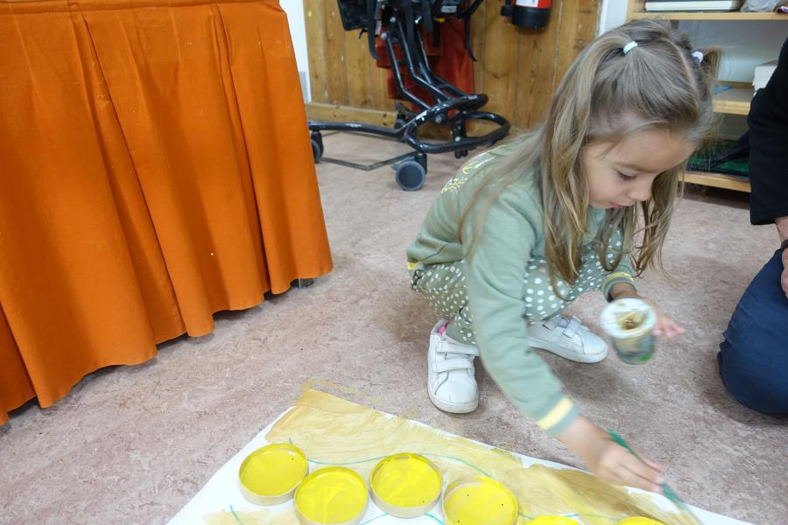
The children made some starfish and we have constructed a giant octopus which has taken all week to make and which I have put up on our theme board this evening. It looks amazing and came together with the help of nearly all the children! Here Diana is painting a tentacle.
This week we will be talking all about “Looking after our seas”, making sure we recycle our rubbish including plastics, we will be making models out of junk, and setting up a market shop selling all sorts of products which we will decide if we can recycle or not.
It is one of our Open Mornings on Thursday, so spread the word to any families you know that have young children ready to start Preschool and that would like to come along and see us at Beehive.
It is going to be a hot week, so sun hats and sun cream please.

Thanks

