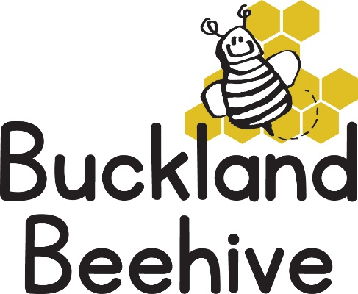

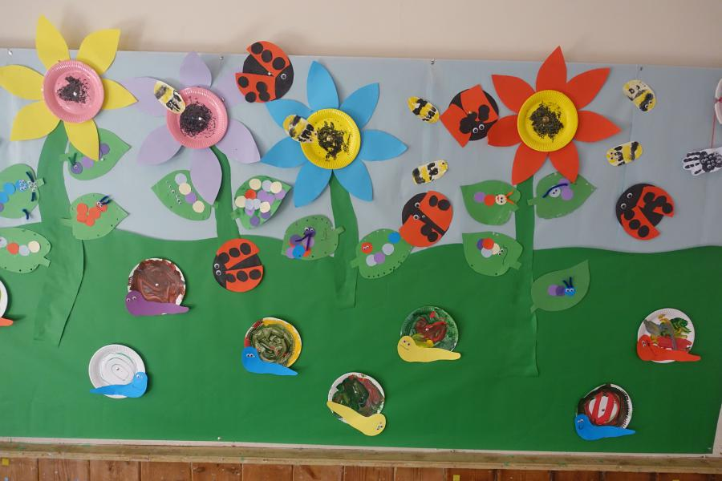
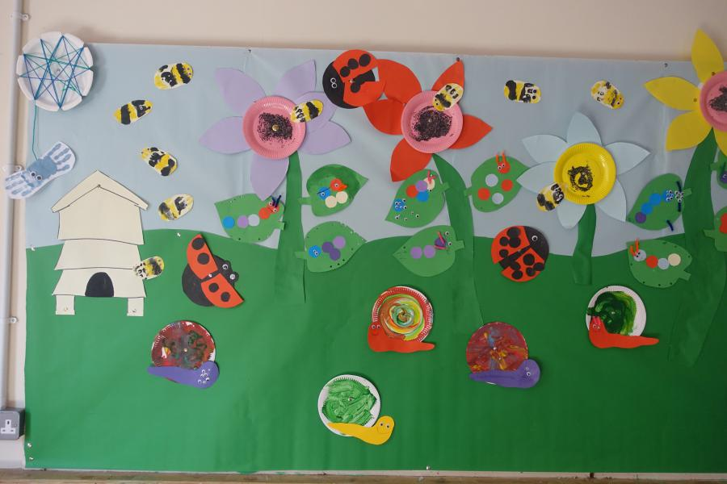
23rd March 2026
Slightly misaligned photo, but this gives you an idea of our lovely theme board this term., the children’s artwork will be coming down in our last week and we will put them in their scrapbooks, great effort by everyone!
We will be looking at all our minibeasts next week, including beetles and ants, which we often find in our garden.
We have had some challenging behaviour from some of our older children recently and we would really like to emphasise being kind to our friends and teachers, practising good sharing and good listening skills. So next week we are holding a “Kindness” week. We will be talking all about our feelings, being kind and helping our friends if they are sad, remembering Please and Thank you, etc. Some discussions at home are also a good idea to reinforce what they are learning at Preschool.
I will be making a “kindness Tree” this weekend, and if we see signs of kindness from the children, they can put a heart on our tree. This will be something we will have permanently at Preschool.
Can I remind parents that are coming to Lambing Live to pay £5, either cash or via BACS straight into our bank account please.
Many Thanks

