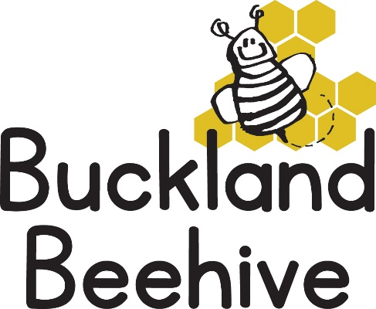

15th June 2026
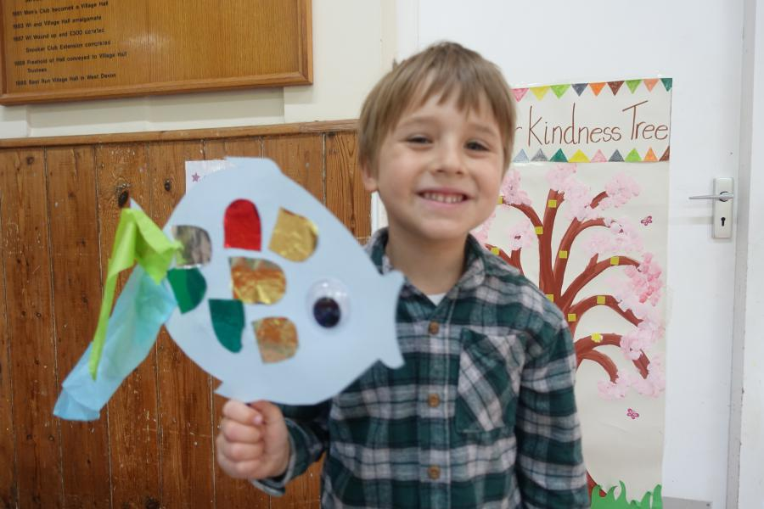
The children made some great rainbow fish last week, and we have started to decorate our theme board, most requests were for us to make a whale or a shark, so we will see!
Looking at all the different creatures under the sea was a lot of fun, and surprising which ones were the favourite of the children, seahorse and octopus as well as the Orca coming out on top.
This week we will be talking about coral and sea plants, as well as adding to our picture with starfish made with cheerios.
The school have informed me that the pool is open from this week. We have been allocated a slot on a Tuesday afternoon, so apologies for those of you that wanted your child to benefit from these trips, we are tied to what the school can give us I’m afraid. We will only be attending if the weather is as warm as Saturday, so the likelihood of that happening for the next 5 weeks is slim.
We have welcomed Daiana to Preschool, she has recently moved to Milton Combe from Ukraine and speaks no English, so we are looking after her for this term before she starts school in September. The children have been very welcoming and we hope she enjoys the short time she has at Beehive.
Many Thanks

