

13th July 2026
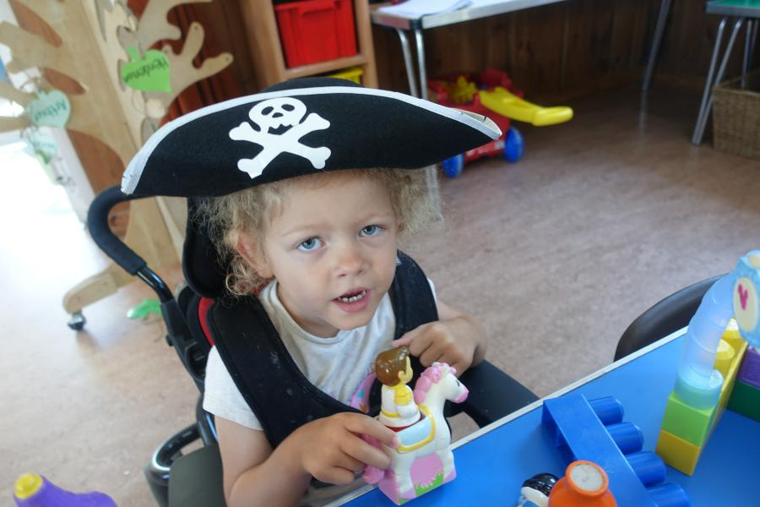
We had a lot of fun being pirates and mermaids last week, hiding treasure, making treasure maps, mermaid mirrors and being role play pirates.
We had a lot of time outside, and when it got too hot, we could play in our environmental back garden under the copper beech trees where it was relatively cool.
This week it is all about the seaside, hopefully some of you may have visited the beach over the weekend. This is the end of our Oceans theme, which the children have really enjoyed learning about.
On Friday, we have our Sports morning, just a few races for the children to take part in. Drop off at usual time, then when all the children have arrived, we will start the games at 9.15am . It usually takes about half an hour, and we will take the opportunity to say goodbye to our leavers as well. Parents and Grandparents are welcome to watch!
In our last week, we are going to have an end of term party on Tuesday 21st July, we have booked a bouncy castle and we will be having lots of fun and games. All the children are invited, even if they are not booked in for a Tuesday, there is no extra charge, it is just our chance to have some fun and relax at the end of a busy term.
If you don’t think your child will be able to join us, can you let me know so I have some idea of numbers. Also, if your child is coming but not usually booked in on a Tuesday, please collect at midday.
Many Thanks

