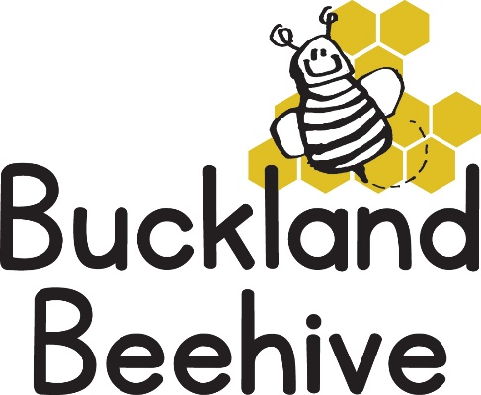

9th March 2026
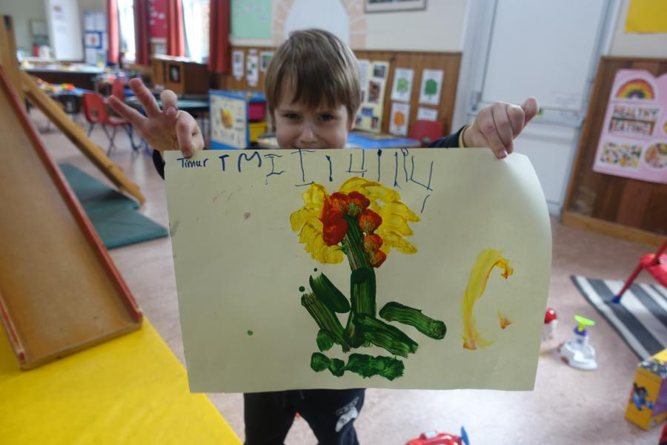
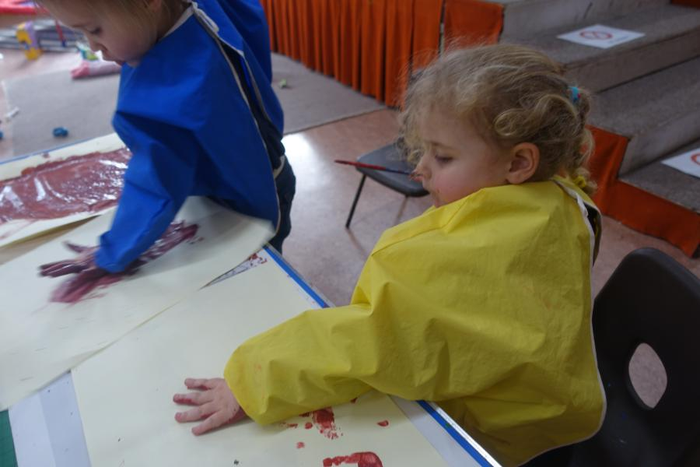
We learnt all about bees last week, we made handprint bees and Timur painted a fabulous flower that I am sure would attract the bees.
It was really lovely to be able to get outside in the sunshine as well. Some of the children enjoyed the honey toast, although something new on the snack plate is not always welcomed!
This week we are entering the realm of the spider, not a minibeast that is a favourite, but we are hoping to tell the children what amazing creatures they are, as well as going on a spider hunt in the garden, we will be making our own webs and spiders.
Phonics this week will be “u” & “b”, and our Makaton signs will be, “your turn”, “my turn”. Again, if you want to see what the signs for these words are google Makaton Signs.
In light of many allergies that are surfacing these days, we can confirm that we are a nut free Preschool. Please be mindful when making your child’s packed lunch.
We have been given a date for Lambing Live!
Monday 30th March, to leave the Preschool by 9.15am or we can meet parents at the farm. I will send a consent form home in your child’s bookbag this week. Please indicate if you are able to attend with your child or not so I can arrange transport. Adults will be £5 each and the children are free.
Many Thanks

