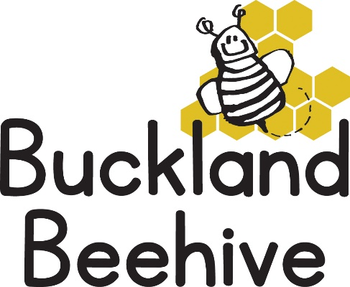

13th October 2025

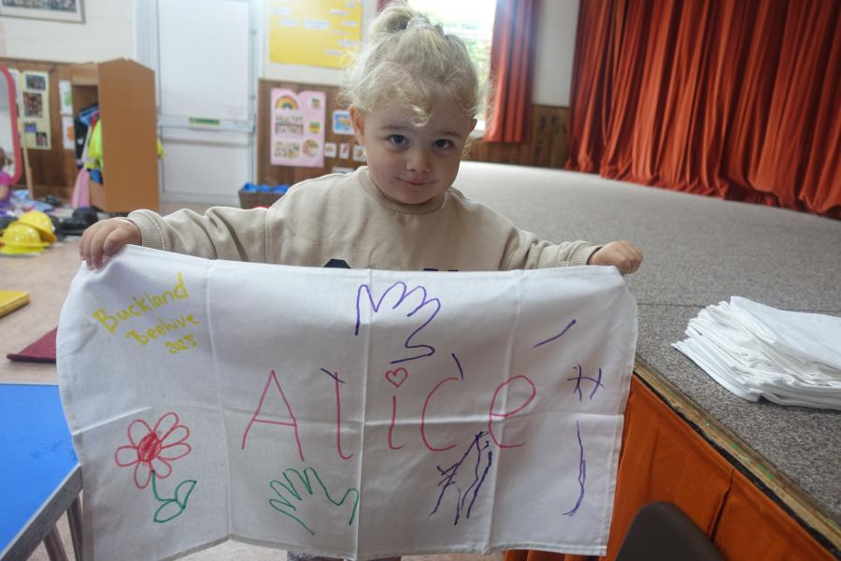We made some little characters this week, dressing them in fabric! And we talked all about what clothes we wear in the summer and in the winter. Some of the children decorated their own tea towel as well.

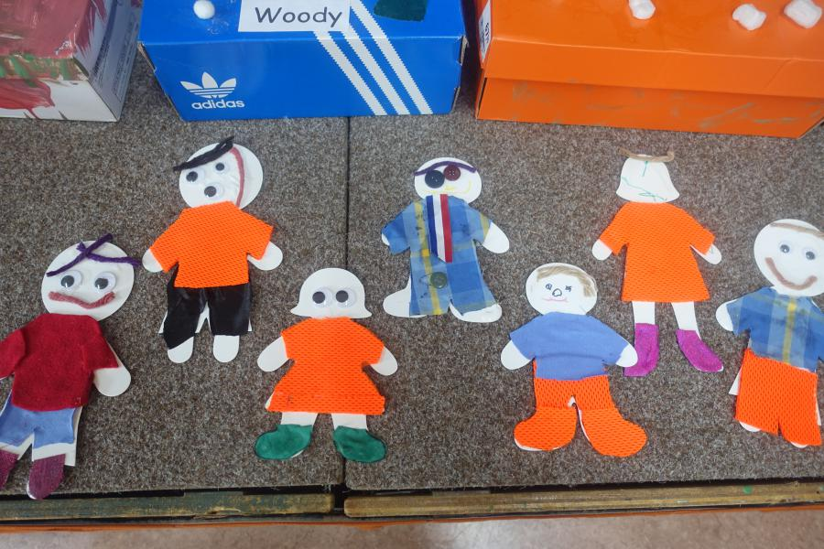This week we will be baking face biscuits, and going over all that we have learnt during the past few weeks, including measuring how tall we are and building towers with the giant bricks, we will have a shop open for food purchases, and making hand and foot prints with paint.

Thank you for all your returned questionnaires, I will be going through them this weekend and get back to you all next week with results.

I have been approached by a friend Emma Warburton, who lives in Crapstone and owns a company with her husband called Greenscheme, they install play equipment at schools, they did Crapstone Playpark, Buckland Playpark, Horrabridge School and the play equipment we have at the back of the hall, to name a few. She is producing a new brochure for the company and has asked if she can take photos of the equipment with some of the children using it?

I will put a consent form in your child’s bookbag and if you could indicate if you are happy or not to have your child included in the brochure and return as soon as you can, that would be great. I am sure she would let us have a copy once it has been produced. Many Thanks