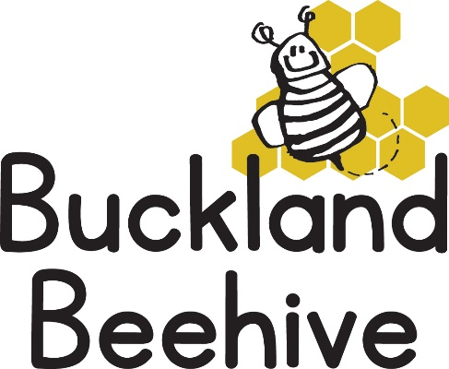

8th June 2026
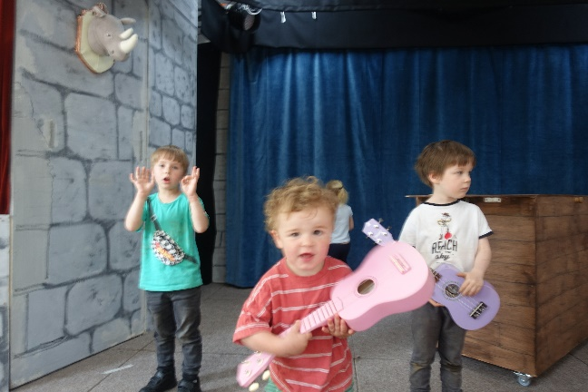
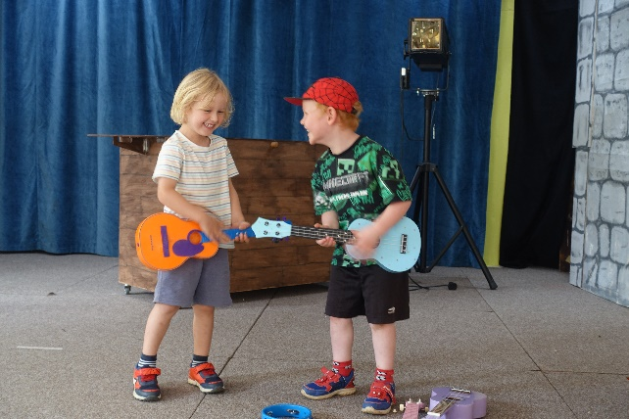
We had a fun week even though we were mostly indoors because of the rainy weather. We thought we would make the most of the stage whilst it is up for the drama performance and the children had an impromptu show on a couple of days. Some were very vocal and others just had the moves, but it was a lot of fun.
We learnt about Planet Earth and that we live on an island surrounded by the Oceans. This week we will be looking at the creatures that live in the sea, reading The Rainbow Fish and making our own rainbow fish too.
If the children have any sea creatures at home that they would like to bring for show and tell, we can talk about each one and learn as much as we can about them.
The first transition session to School went really well, we hope these sessions will make it easier for the children as they become more familiar with the classroom and staff.
Many Thanks

