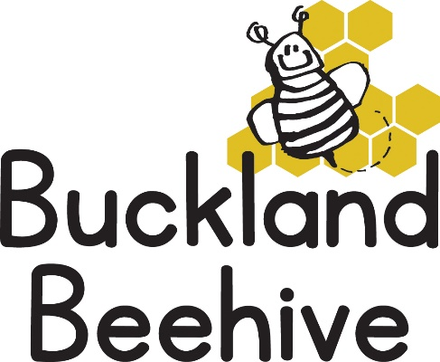

6th October 2025

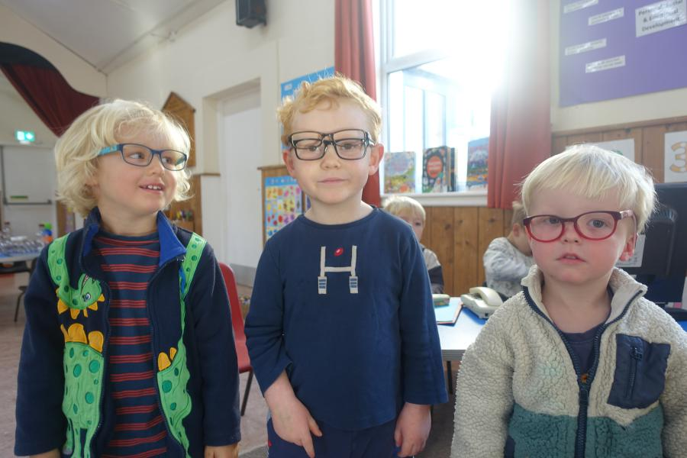We really enjoyed our Senses week and had lots of great activities for the children to enjoy.

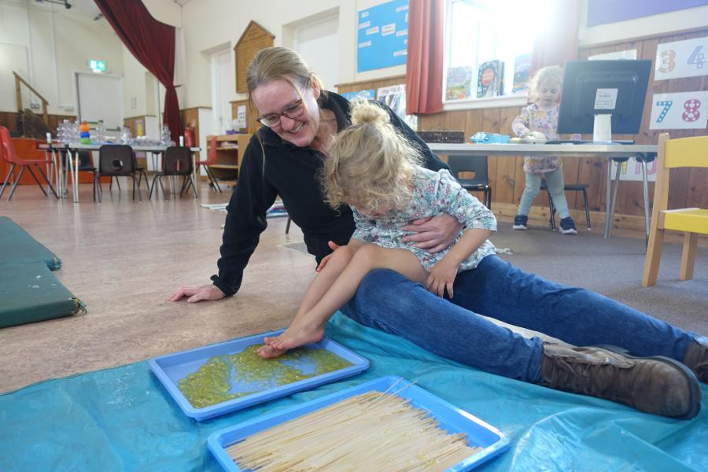Here the boys are trying out some glasses from our Opticians shop! There are more hilarious photos on the webpage.

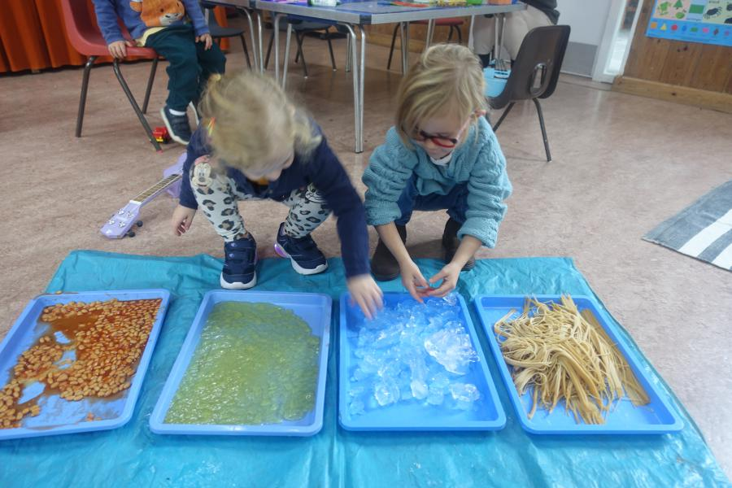Even Polly tried the jelly, spaghetti, baked beans and ice on her feet! While some of the other children used their hands

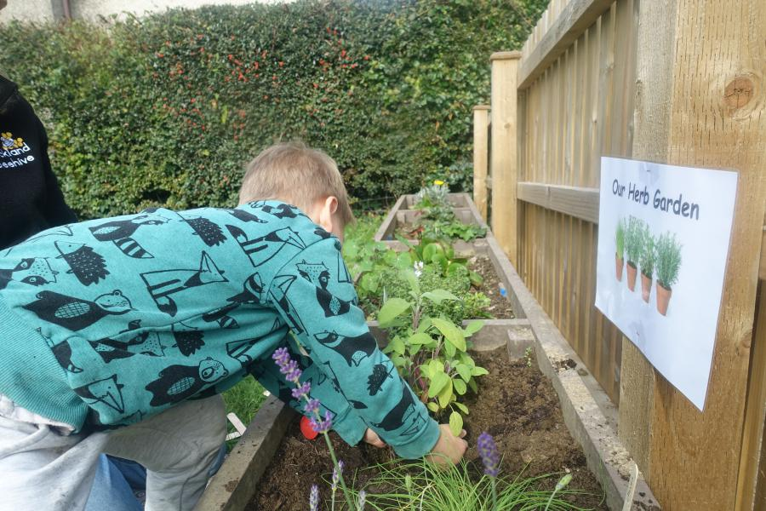They all made a shaker on the craft table and we planted a sensory herb garden in our planters outside.

This week we will be looking at the clothes we wear, and uniforms. Talking about the different clothes we wear in Winter and Summer, and the different sizes of clothes from baby clothes to adult clothes. If any parents wear a uniform for their job, feel free to come in and show us all! We will be designing our own tea towels, and dressing cut out dolls. So another busy week at Beehive!

Thank you for the completed questionnaires, keep returning them, a box will be outside for you to use.

Recently the local Community Orchard had a day of picking apples, which was really great fun as I joined lots of volunteers in the rain, it has been a bumper year and there are loads of bottles of apple juice available to buy, we had one at Beehive last week for the children which they tried. If any one would like to order some, do let me know so I can arrange collection for you. A price list and a sample will be outside the front door next week.

A Birthday celebration for Timur on Friday, he will be 4 years old!

Many Thanks