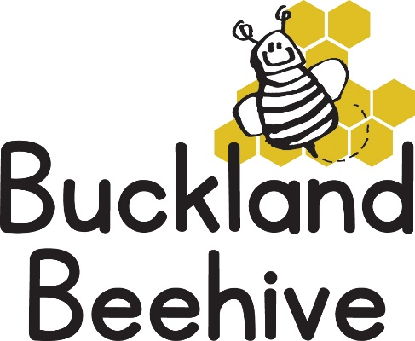

3rd November 2025
Welcome back! We hope you all had a great half term. We return to the build up to Christmas, which is such a lovely time of year.
Our theme this half term is Fairy Tales, beginning with The Gingerbread Man. We will be cooking our own Gingerbread men and women and have ginger playdough available. Fairy tales are a great way for the children to engage with stories and rhymes and learn through repetition enabling them to retell the stories they hear.
There are a number of events happening this half term, so I will give you some dates to put in your diaries and provide more information nearer the time.
St Andrews School Christmas Fair Friday 28th November – We usually have a soft toy Tombola at the fair, so if any of you have any soft toys you would like to donate, that would be appreciated. Any money made goes towards our Christmas Party.
The Village Hall Coffee Morning and Christmas Fair Saturday 6th December 10am until 12 noon – everyone is invited, lovely stalls for stocking fillers and yummy things to eat!
Beehive Christmas Show Friday 12th December 9.15am – the children will be performing a little show of Christmas songs and rhymes. It usually takes about half an hour, everyone is welcome. I will be sending out a song sheet to you all so you can practise at home as well.
Christmas Party Friday 19th December - This is the last day of term. We will have a visit from Father Christmas, followed by a party lunch and fun and games. Further details to follow.
Many Thanks

